**Assignment -1**

Python Flask

|  |  |
| --- | --- |
| Assignment Date | 27 September 2022 |
| Student Name | Mr. Naveenkumaran R |
| Student Roll Number | 711319CS101 |
| Maximum Marks | 2 Marks |

**Question-1:**

1. Create User table with user with email, username, roll number, password.

**Solution:**

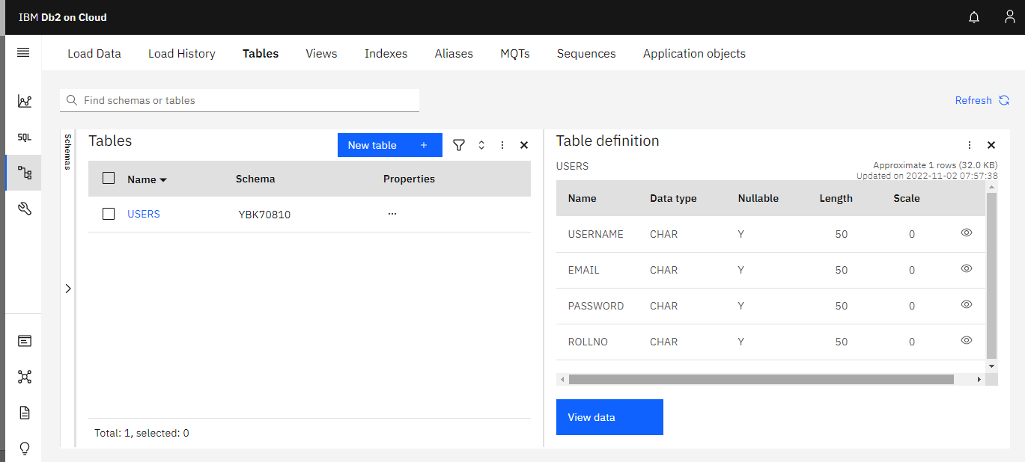

**Question-2:**

1. Perform UPDATE,DELETE Queries with user table?

**Solution:**

**Update**

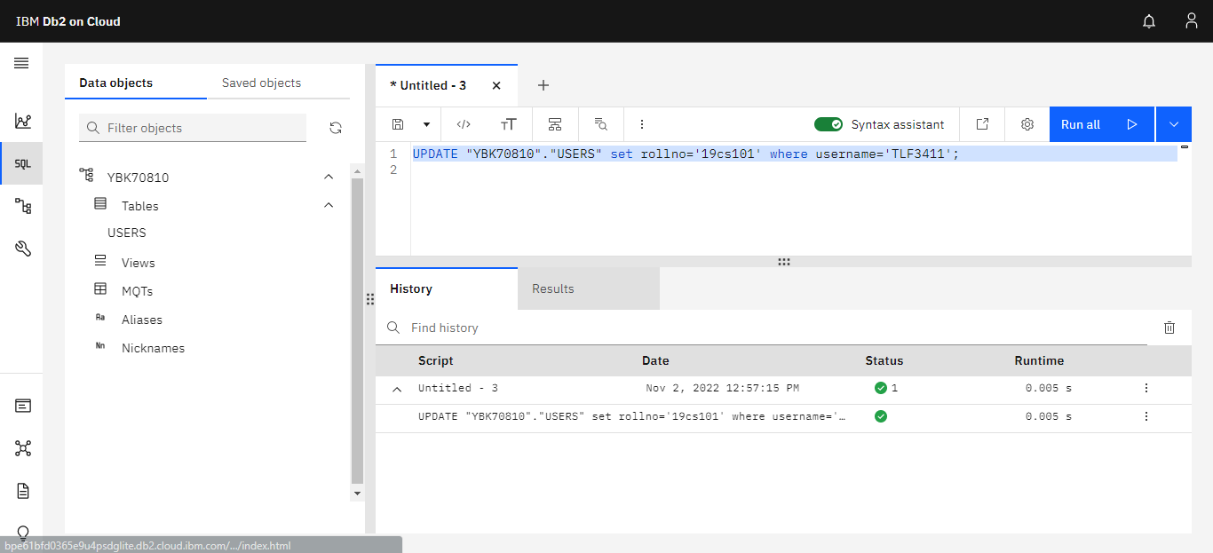**’**

**Delete**

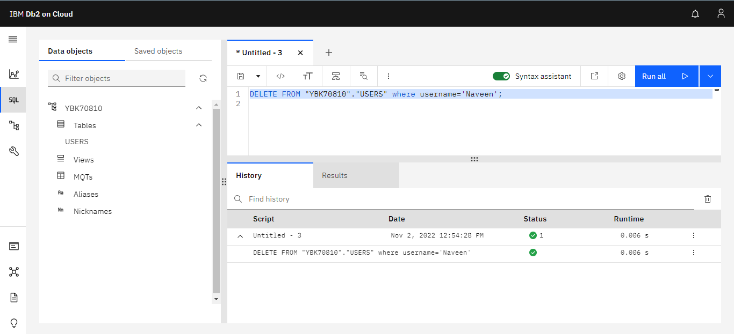

**Question-3:**

1. Connect python code to db2?

**Solution:**

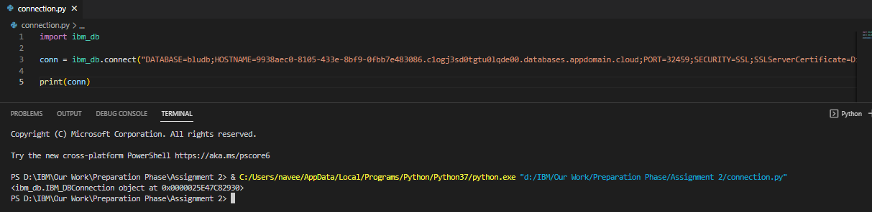

**Question-4:**

1. Create a flask app with registration page, login page and welcome page. By default load the registration page once the user enters all the fields store the data in database and navigate to login page authenticate user username and password. If the user is valid show the welcome page?

**Solution:**

**Display.html**

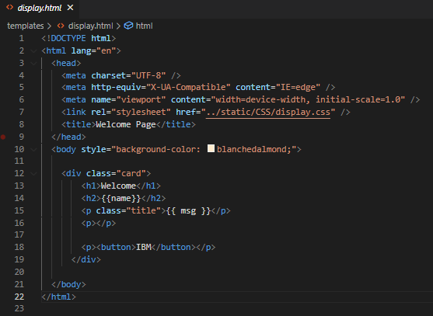

**Login.html**

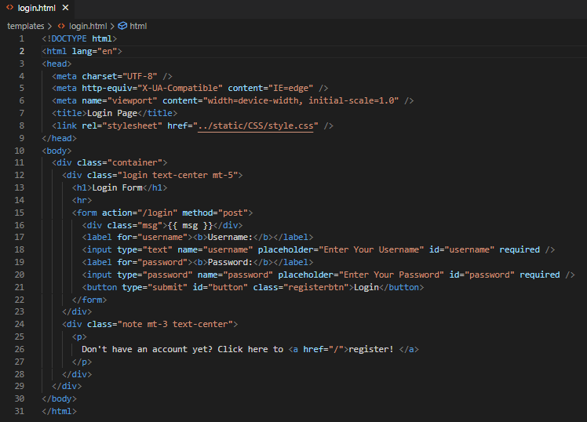

**Register.html**

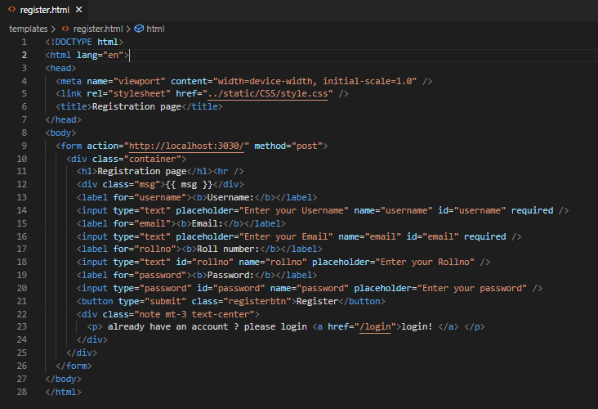

**Display.css**

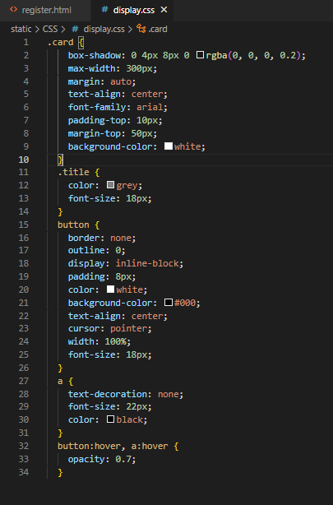

**Style.css**

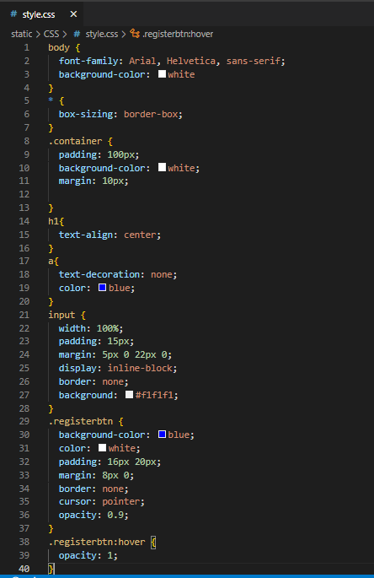

**App.py**

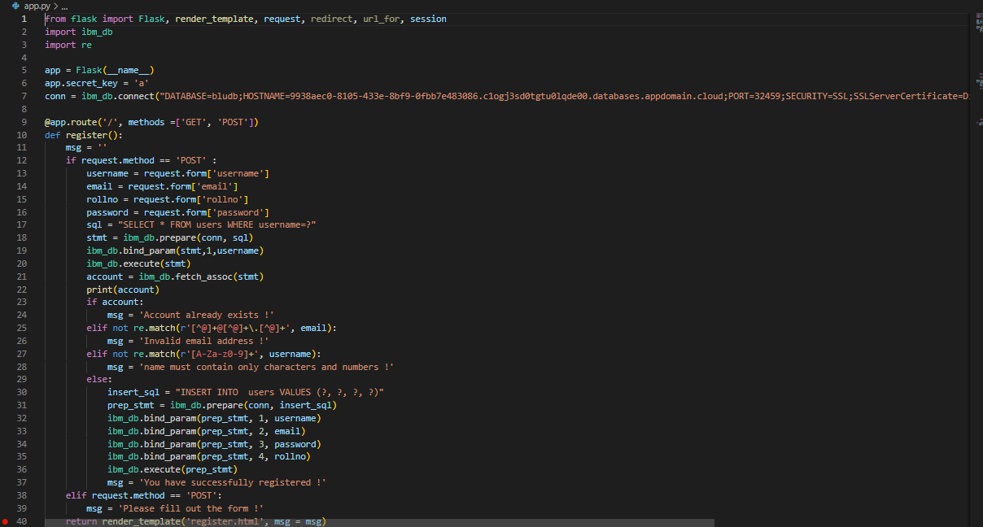

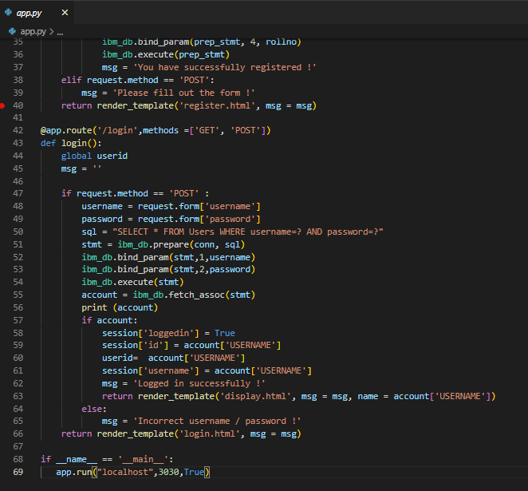

**Registration Page**

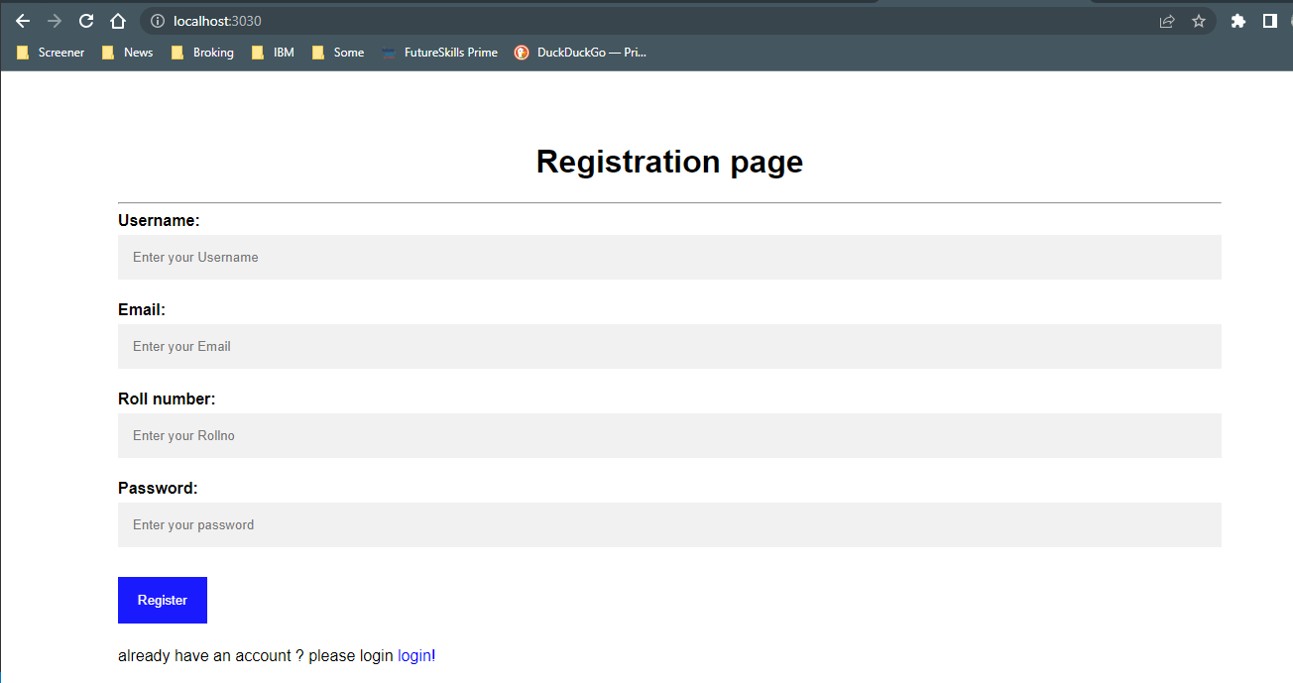

**Login Page**

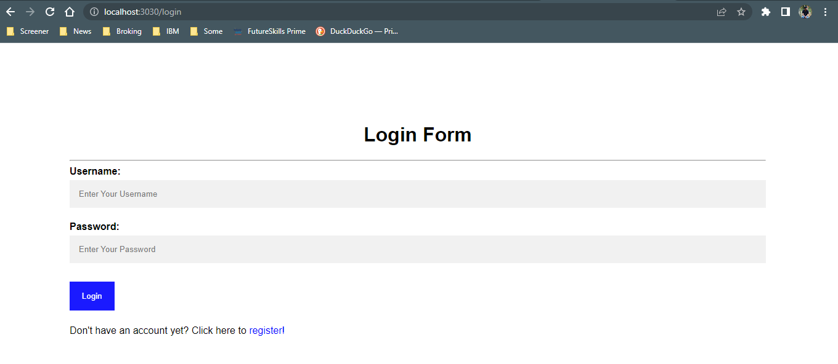

**Welcome Page**

